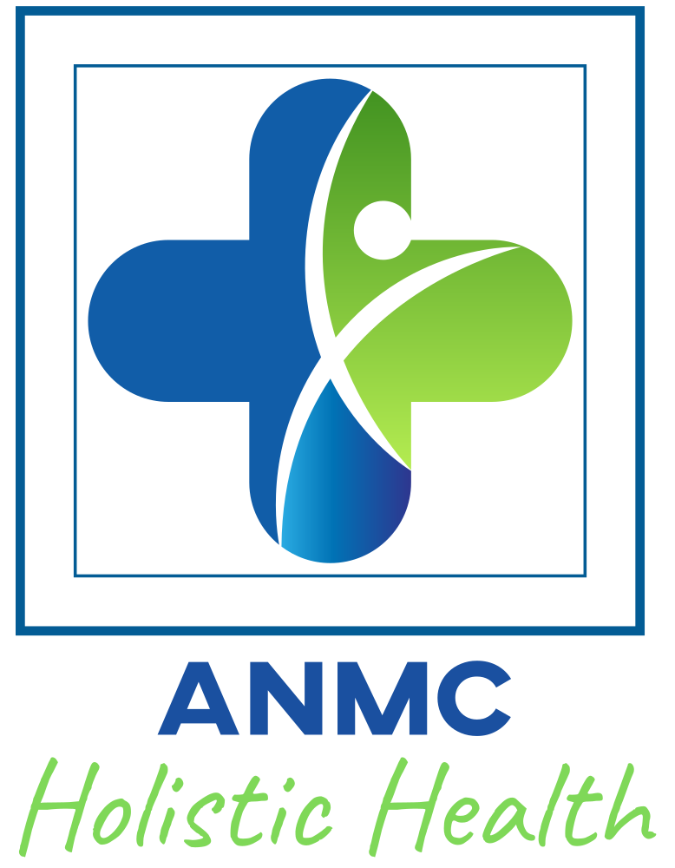
Retrain the Allergy Brain
Self Assessment Questionnaire

Yes No
O O Do you have symptoms with no diagnosis, or treatment and still symptoms?
O O Are you a “mystery” case that no one can seem to figure out?
O O Have you been on multiple antibiotics in your past?
O O Do you have a history of a specific trauma?
O O Do you have a history of feeling very stressed?
O O Have you had a major illness that you can remember was stronger than a cold?
O O Have you had an abdominal surgery?
O O Have you had any organs removed?
O O Have you gone through surgery of any kind?
O O Have you had a c-section?
O O Have you been pregnant?
O O Have you had miscarriages?
O O Have you ever questioned that you need to “detox” your body?
O O Have you ever lived in a house over 60 years old?
O O Have you ever lived in a house that is brand new?
O O Have you remodeled your home or office?
O O Do you work with toxic chemicals at your job?
O O Do you suffer from unexplained symptoms?
O O Have frequent headaches?
O O Do you have trouble sleeping?
O O Do you feel tired or rundown a lot?
O O Do you feel tired but “wired” and can’t sleep?
O O Do you have symptoms that treatment hasn’t helped with?
O O Do you feel you have to avoid certain foods to reduce symptoms?
O O Do you suffer from anxiety, depression, or panic attacks?
O O Do you worry a lot?
O O Do you feel fearful a lot?
O O Do you wake up feeling sad or melancholy/hard to start the day due to mood?
O O Do you experience sensitivities to food, chemical, smells, light, or EMF?
O O Do perfumes, cleaners, or other smells make you feel ill?
O O Do you dwell on past events?
O O Do you have difficulty taking medications?
O O Does it seem like you are intolerant to many things?
O O Does it seem like if something is going to go wrong during a procedure it will to you?

If you answered to more than 10 of these questions, it is highly possible that you could be experiencing issues of dysfunction or imbalance in functional systems as well as of limbic and vagal impairment. We do not diagnose disorders, but it is likely that you can benefit from conditioning and functional re-training to activate the body’s healing responses.

**We do not diagnose, treat, heal, cure or prevent any illness, medical condition or mental or emotional condition and this questionnaire nor anything on our website, its content or in our services is intended to diagnose, treat, heal, cure or prevent any illness, medical condition or mental condition. ANMC Holistic Health, LLC provides functional wellness, optimal health, and mind body information and education. Our services are not medical or mental health advice. Amanda E. Plevell is a Certified Natural Health Practitioner, not a licensed medical or licensed mental health professional. Nothing on our website, in our Content or in our Services should be construed as healthcare or mental health advice or as a substitute for a consultation with a licensed medical or licensed mental health professional who can review and advise you on your specific situation. Anyone choosing to implement any information on our website or in our Services should obtain prior medical clearance from a licensed medical or licensed mental health professional to declare them sufficiently healthy, and determine that the information on our website or in our services is appropriate and useful for them. If you choose not to consult with a healthcare professional before using any information on our website or in our Services, you assume all risk for any and all results. Do not disregard professional medical advice, stop taking medications, stop any treatments or delay seeking professional advice because of information you have read on our website, or received from us. Coaching is in no way to be construed as psychological counseling, therapy or medical advice. Working with us is not a guarantee of any results. ANMC Holistic Health LLC owns all copyrights to the materials presented here unless otherwise noted.

